UI design Notes

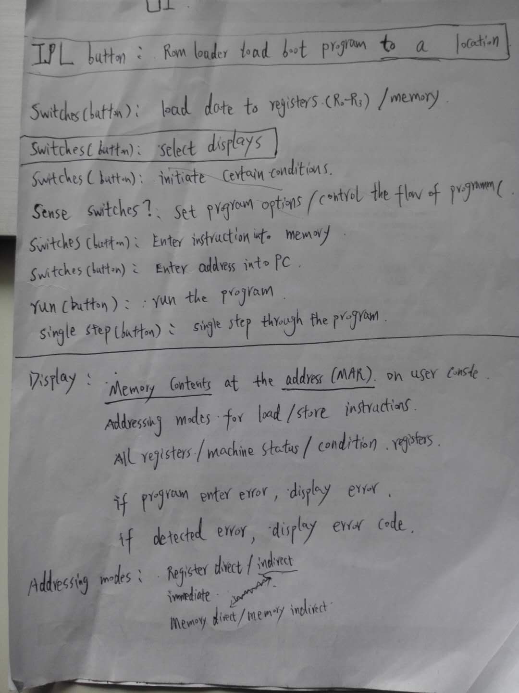

Compiler design notes

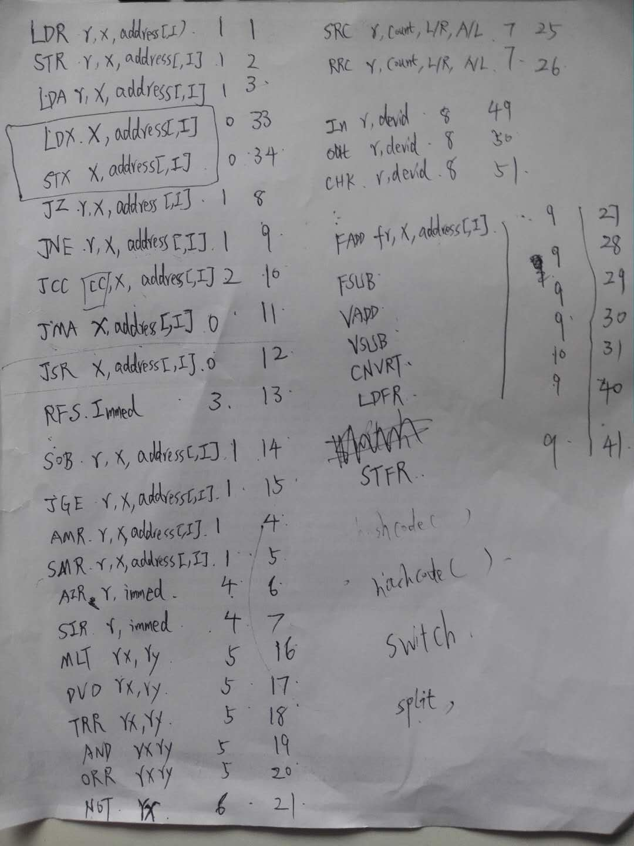

CPU and Memory design notes

Class Diagram

1. Simulator works as computer which includes two components, CPU and memory. To run the computer, you need to load instructions to the memory and initialize the CPU properly. For example, you need to set the PC register to the address of the first instruction.
2. The CPU has five parts works in turn to execute an instruction. They are the Fetch, Decode, Execute, Memory accessing and Register write back components respectively.
3. The CPU has two components: Registers and Instruction, to store run time status temporarily. Registers represents the register file of the CPU. Instruction component stores status of the instruction which is running.
4. Most of the components have an interface to define the API provided by it and an implementation class which includes the details of how the APIs are implemented. For instance, *interface* ***CPU*** defines the APIs of the CPU such as *initialize*, *run* and *runSingleStep*. On the other hand,

CPU

Simulator

Memory

Fetch

Decode

Execute

Memory UP

Writeback

Registers

Instruction